CSCI222 Assignment 2 Report

Team Number : <C6>

 | Student Number | Name | Email Address
1 | 5281374 | Mei Konishi(Team Leader) | Tel :+65 96974658  Email : konishi001@mymail.sim.edu.sg
2 | 5710923 | Chua Han Ming Adler | hmachua002@mymail.sim.edu.sg
3 | 5281477 | Tao Si Yue | ts003@mymail.sim.edu.sg
4 | 5711289 | Nicola Tan Yin Ci | nnycchin001@mymail.sim.edu.sg
5 | 5498338 | Wee Hon Sen Daryl | hsdwee001@mymail.sim.edu.sg
6 | 5711356 | Ong Wei Hao | whong012@mymail.sim.edu.sg
7 | 5710479 | Loh Si Ying | syloh007@mymail.sim.edu.sg

Table of Contents
1. Project Overview 4
1.1 Vision 4
1.2 Initial Use-Case Model 4
1.3 Project Plan 4
2. Roles and Responsibility 5
3. Risk Analysis and Counter Measures 6
4. Design Artefacts 7
4.1 Use Case Iteration 1 7
4.2 Use Case Iteration 2 8
4.3 Activity Workflow Iteration 1 9
4.4 Activity Workflow Iteration 2 10
4.5 Component Diagram Iteration 1 11
4.6 Component Diagram Iteration 2 12
4.7 Class Diagram Iteration 1 13
4.8 Class Diagram Iteration 2 14
4.9 Sequence Diagram Iteration 1 15
4.10 Sequence Diagram Iteration 2 16
4.11 Deployment Diagram Iteration 1 17
4.12 Deployment Diagram Iteration 2 18
4.13 Bug Testing 19
4.14 Test Plan Design 20
5. Appendices 21
A. Formal Meeting Records 21
1. Construction Phase - Iteration 1 21
2. Construction Phase - Iteration 2 24
3. Transition Phase - Iteration 1 27
B. Individual Work Diaries 29
1. Team Member 1: Mei Konishi 29
2. Team Member 2: Loh Si Ying 32
3. Team Member 3: Chua Han Ming Adler 35
4. Team Member 4: Ong Wei Hao 38
5. Team Member 5: Nicola Tan Yin Ci 41
6. Team Member 6: Wee Hon Sen Daryl 44
7. Team Member 7: Tao Si Yue 47
C. Evidence of Using VCS (Version Control Software) 50

Project Overview

1.1 Vision
The creation of a warehouse inventory management system coded in C++ to work on a Linux OS. The system will require a valid login to access the system and three failed attempts will lock that account. All data related to the login is to be encrypted.

The system shall provide the user with the ability to add to, remove, search and/or edit stock items within the database. The user will also be able to process transactions of items within the warehouse.The system shall display a summary of transactions within a certain time period based on the user’s input.

Initial Use-Case Model
This initial use-case model was designed according to the functionally requirements from appendix A’s functional requirements. There would 7 main functions that users do in this program.

- Login
- Add new stock
- Remove stock
- Edit stock item
- Process stock item
- Search stock item
- Print summary report

Project Plan
Please refer to document “CSCI222_Assn2_GanttChart.xslx”.

Roles and Responsibility

Team Number : C6

 | Student Name | Role | Artefacts
1 | Mei Konishi | Manager  Implementer | Sequence diagram (5, 5.1 and 6), Coding
2 | Adler Chua | Lead Tester | Test case template, User Acceptance Test Case (No 6-11) and Bug Test version 0.01-0.07
3 | Loh Si Ying | Implementer | Class Diagram, Implementing on Transaction class and Edit Stock Function in Management Class, Gantt Chart
4 | Nicola Tan | Tester | Deployment Diagram, Sequence Diagram (5.2 to 5.5, 6.1 to 6.2, 7 and 8), Remove Stock Item Function, User Acceptance Test Case (No 1-5, 15), Nicola - bug testing 0.08
5 | Tao Si Yue | Tester | Search Stock Function, Sequence Diagram (1 to 4), Component Diagram, User Acceptance Test Case (No 12-14, 16-19)
6 | Daryl Wee | Lead Implementer | SVN,
7 | Ong Wei Hao | Documenter | Final report compilation, Meeting Minutes, Add new stock function.

Risk Analysis and Counter Measures

 | Impact Type | Risk Seriousness (%) | Likelihood of Occurrence (%) | WBS  (affected work / task ) | Risk Description
1 | No sense of time | 90% | 30% | Entire project | All members cannot hand up the work on time as needed them to do.
2 | Sick | 50% | 30% | Task given to that member | Members all fall sick when doing the project due to food poisoning or etc
3 | Family Matter | 30% | 3% | Task given to that member | Member has funeral to attend for few days leading to backlog of work needed to do and not able to meet time set for him.
4 | Hard Disc Crash | 90% | 10% | Entire Project | All the work done is just gone.
5 | Mental Breakdown | 60% | 30% | Task given to that member | Too stress and members just cannot cope and eventually lead to unstable mental

 | Risk Description | Proposed Mgmt Plan | (Possible) Reduction in Risk Seriousness (%)
1 | All members cannot hand up the work as needed them to do. | Plan 1 : Set a designated timeline for any piece of work needed to be done by them | -70%
1 | All members cannot hand up the work as needed them to do. | Plan 2 : Set meetings every 3 days to check the progress of the members’ work and pin point out the urgency of the task | -20%
2 | Members all fall sick when doing the project due to food poisoning or etc | Make sure the members seek doctor and rest well and recuperate well enough to continue the task he is needed to do. A break or two is good for members to get back to healthy state to do task more efficiently | -50%
3 | Member has funeral to attend for few days leading to backlog of work needed to do and not able to meet time set for him. | Let the member settle his family issue in peace thus allowing to have the right mindset to continue his task else it will affect everything he is going to do if he did not get to settle his issue properly. | -30%
4 | All the work done is just gone. | Constantly save files and update in various platform so if one place crashes, there will still be copies of the file elsewhere | -90%
5 | Too stress and workers just cannot cope and eventually lead to unstable mental | Make sure the member don’t feel pressurized by the team manager when the work he produced is not up to standard, and try not to try him | -60%

Design Artefacts

Use Case Iteration 1

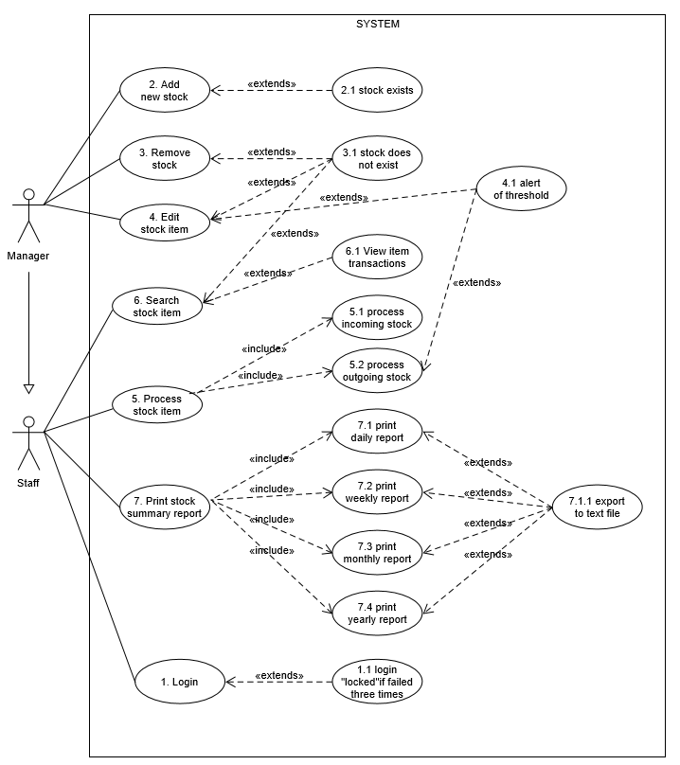

Use Case Iteration 2
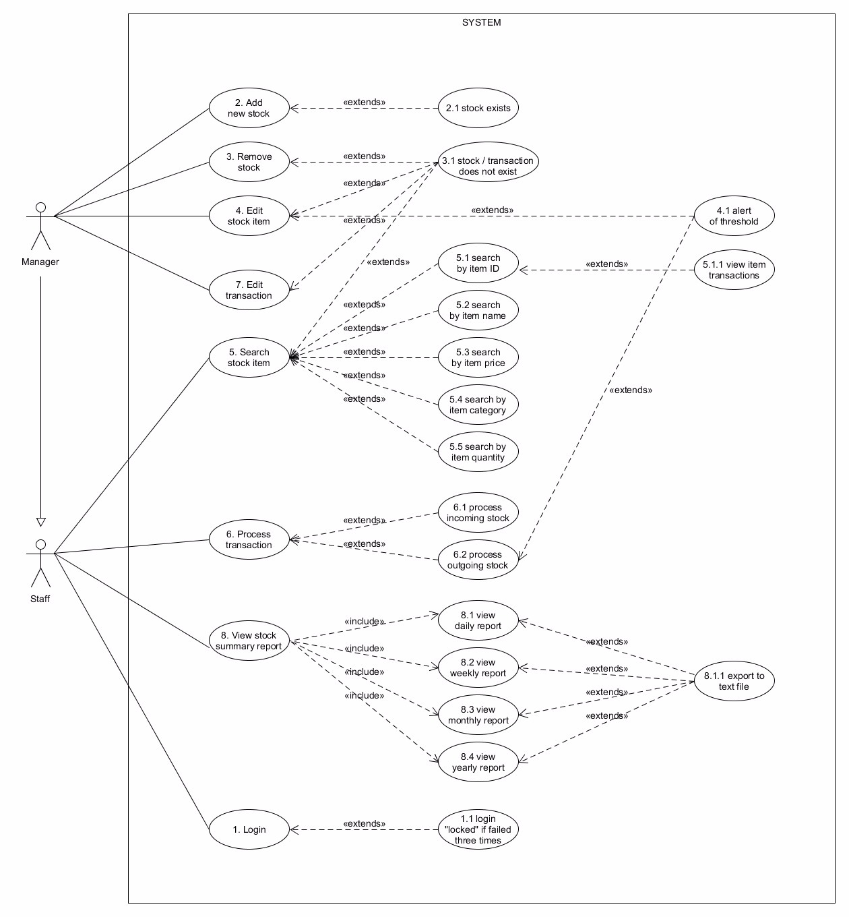

Activity Workflow Iteration 1

Please refer to Appendix A of document “CSCI222_Assn2_Appendix.doc”.

Activity Workflow Iteration 2

Please refer to Appendix B of document “CSCI222_Assn2_Appendix.doc”.

Component Diagram Iteration 1

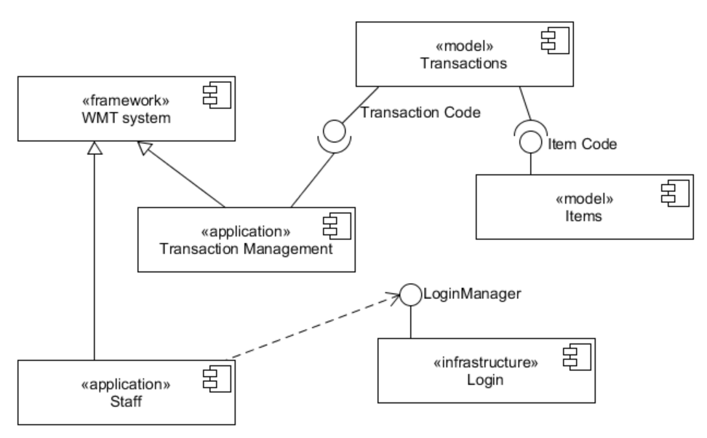

Component Diagram Iteration 2

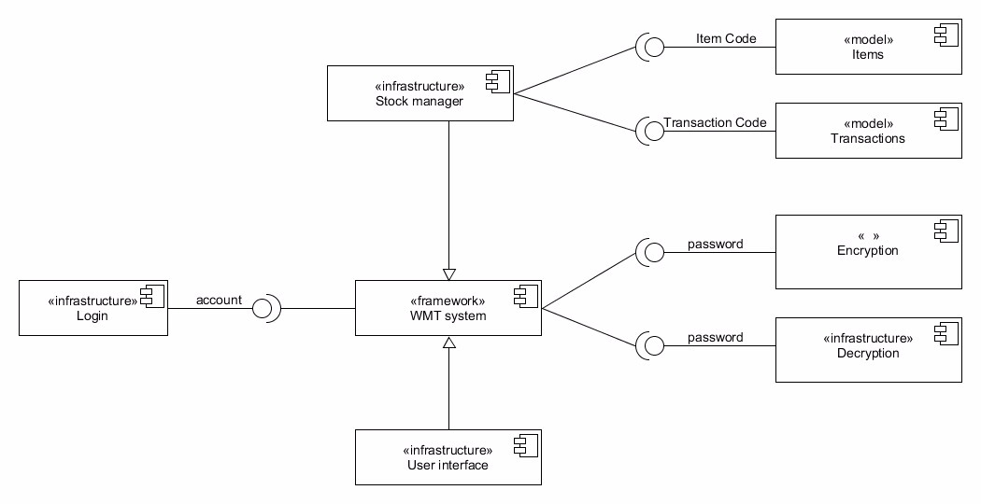

Class Diagram Iteration 1

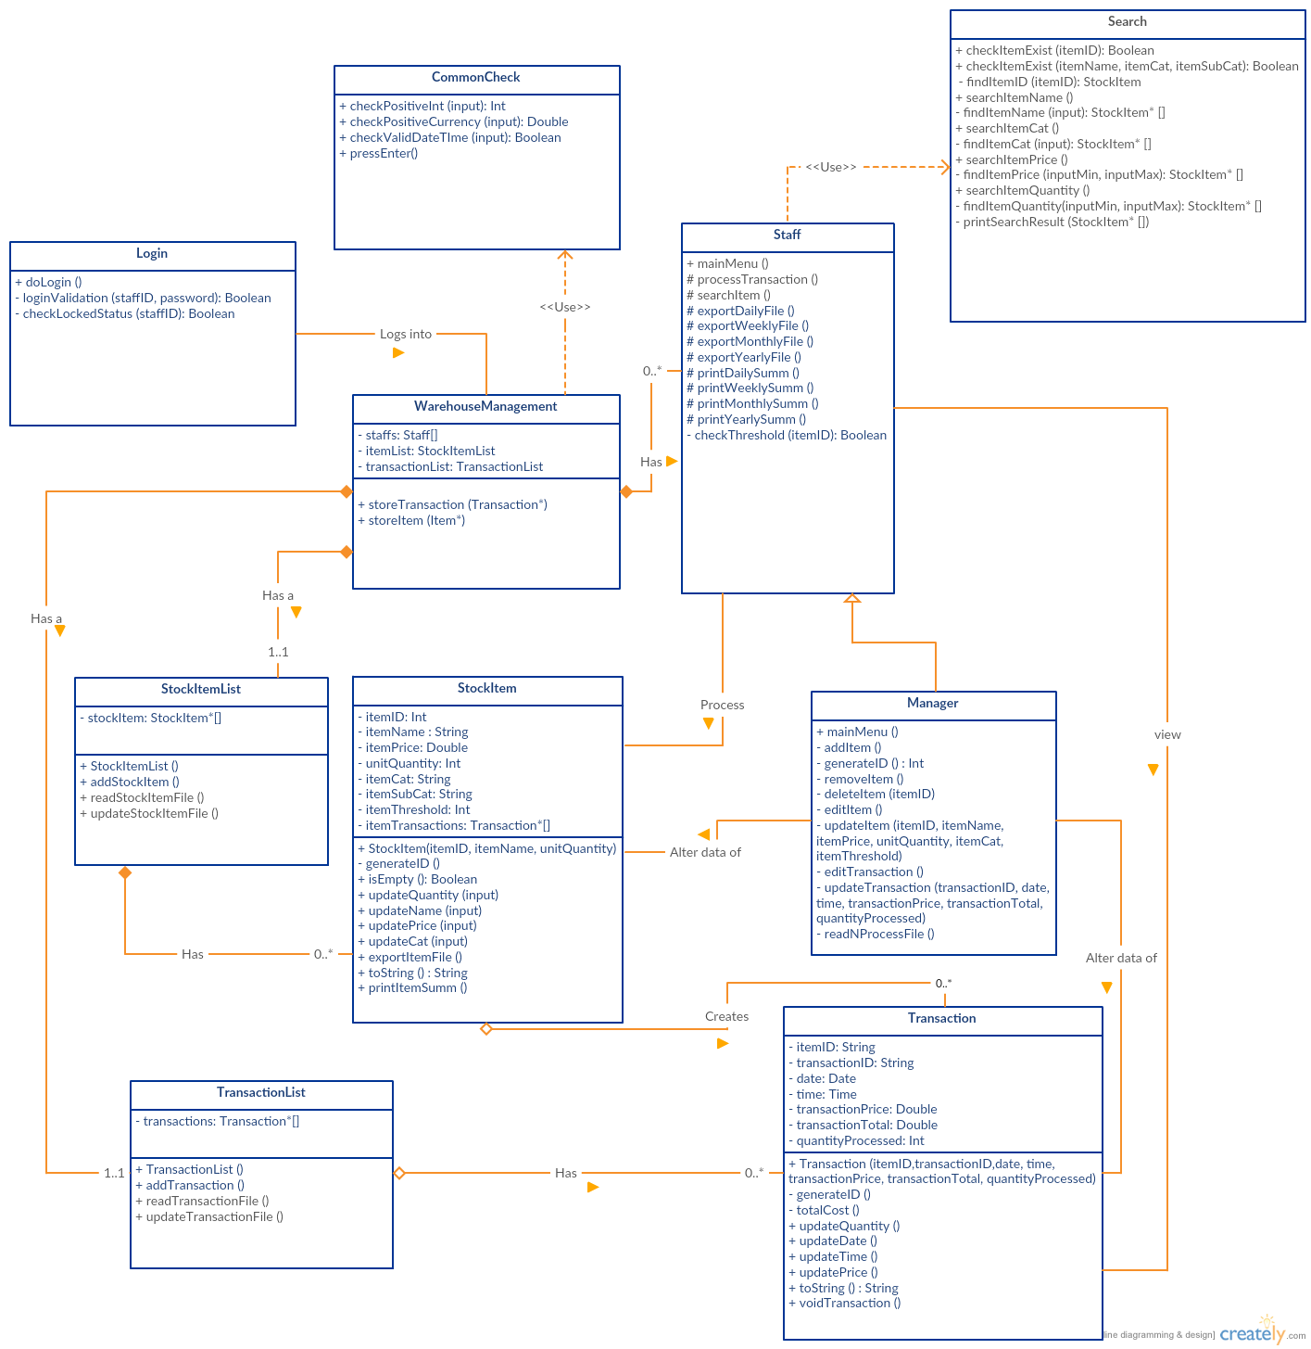

Class Diagram Iteration 2

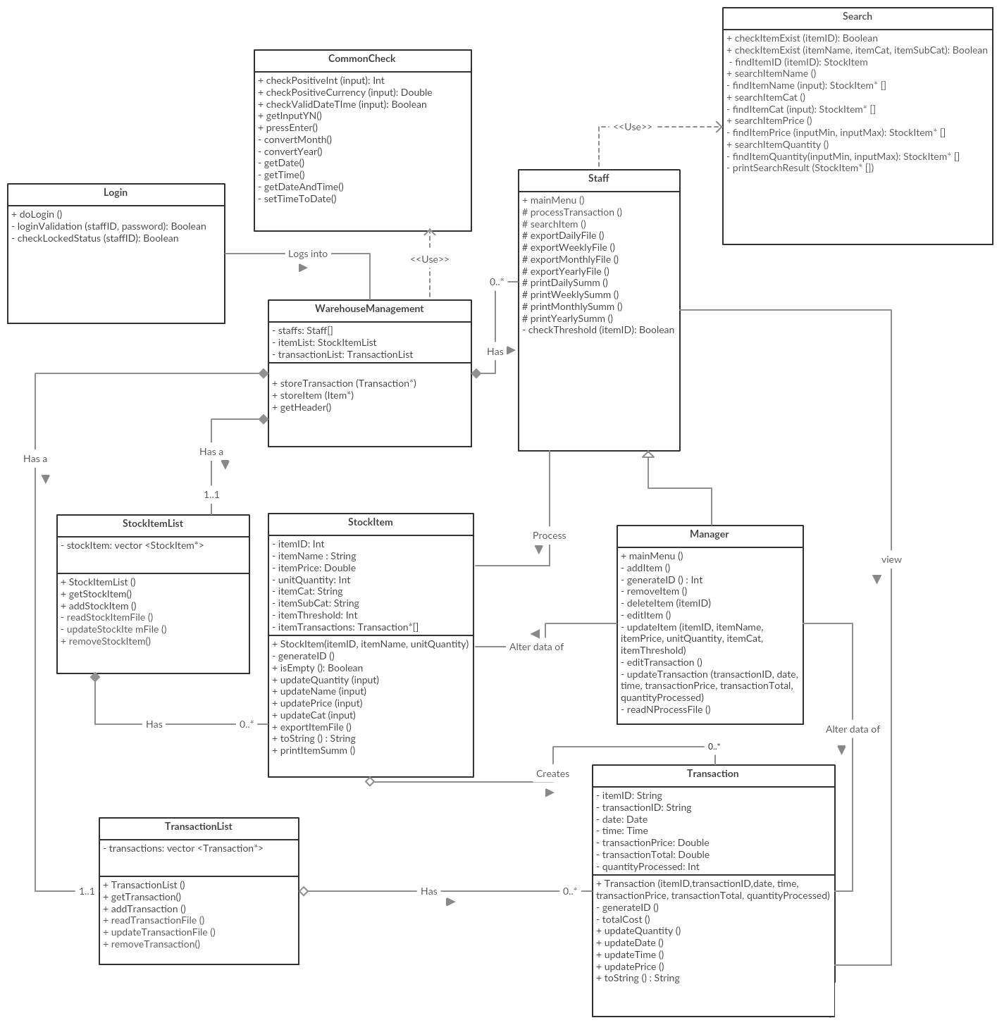

Sequence Diagram Iteration 1

Please refer to Appendix C of document “CSCI222_Assn2_Appendix.doc”.

Sequence Diagram Iteration 2

Please refer to Appendix D of document “CSCI222_Assn2_Appendix.doc”.

Deployment Diagram Iteration 1

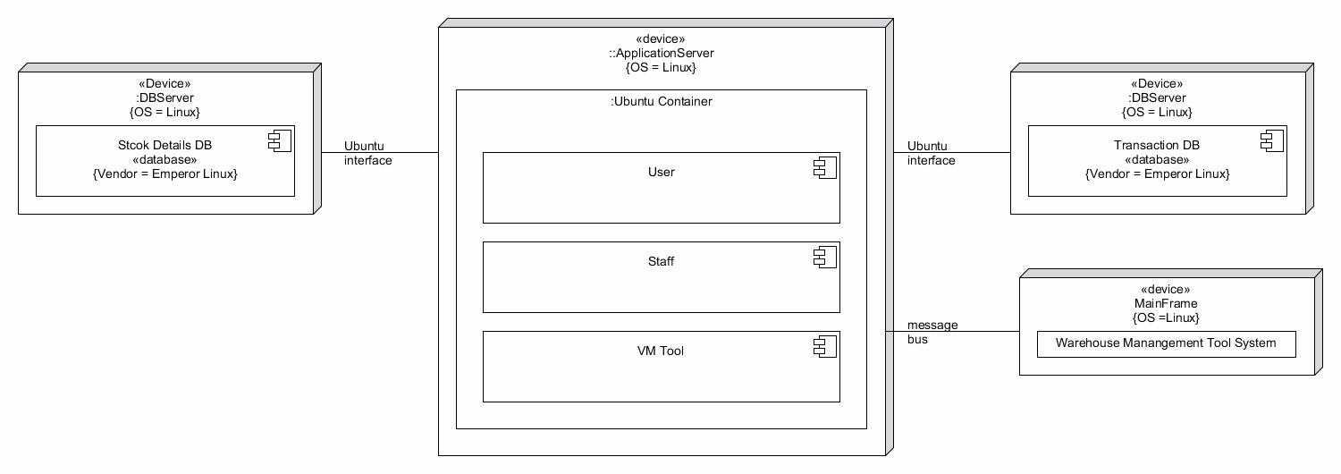

Deployment Diagram Iteration 2

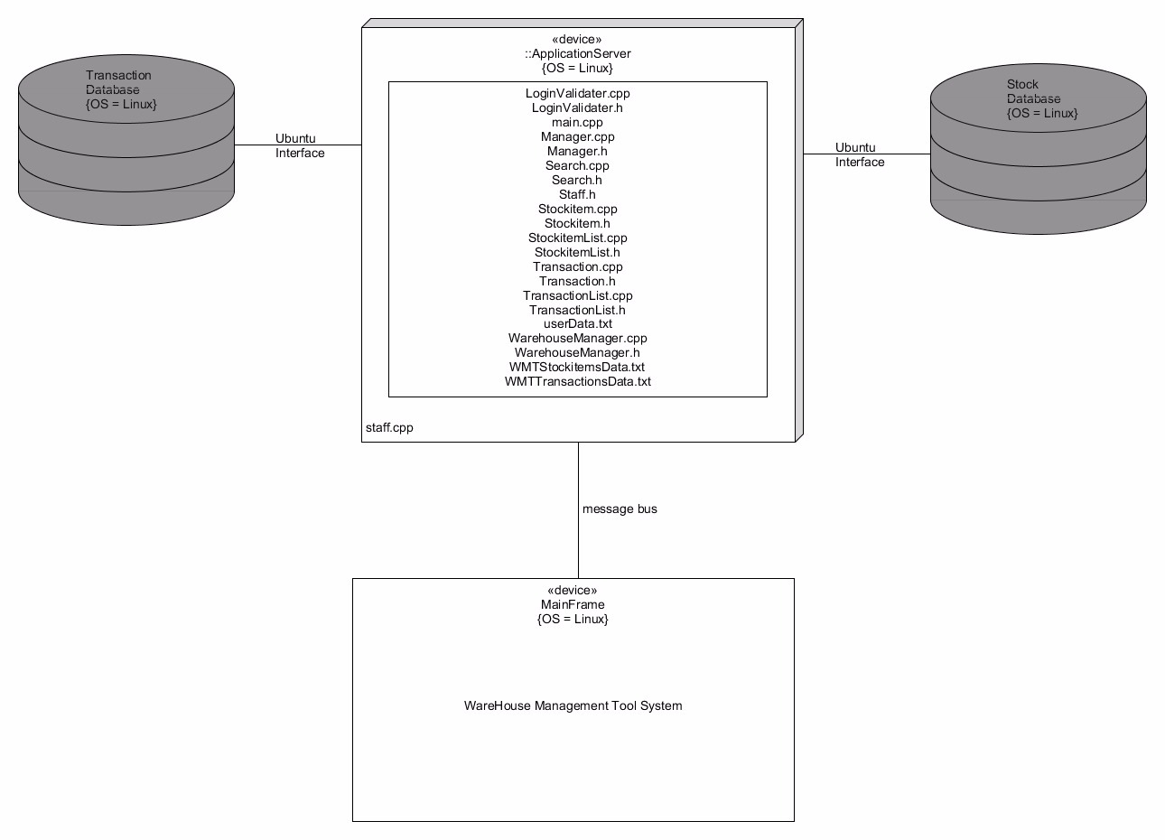

Bug Testing

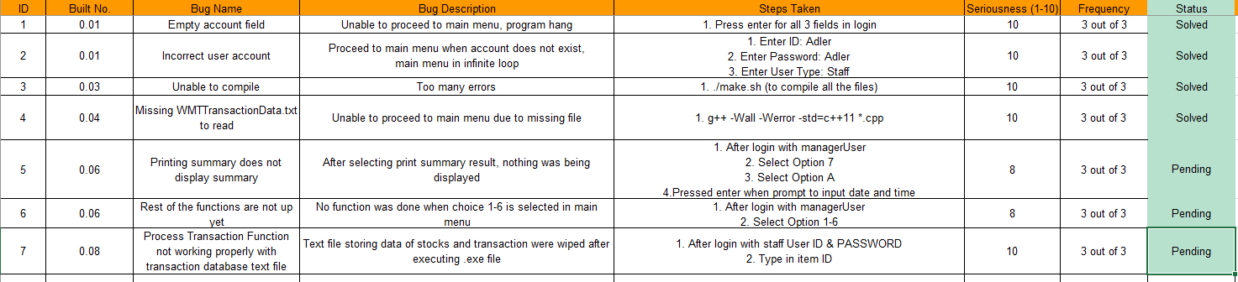

Test Plan Design
Please refer to document “User Acceptance Test”

Appendix A - Formal Meeting Records

Appendices

A. Formal Meeting Records

Construction Phase - Iteration 1

PROJECT Meeting Minutes

Date: | 20/02/17
Meeting no. | 01
Venue: | SIM Block A level 4
Present:
Loh Si Ying
Mei Konishi
Tao Si Yue
Nicola Tan
Daryl Wee
Ong Wei Hao
Adler Chua

Absent with apologies:
NIL

S/No | Item
Meeting started at 1200pm

Agenda
Understand what went wrong with the previous presentation and the mistakes pointed out
Understand job scope of individual member
Identify the work load and divide among team members

Conversation

Mei: Agenda of the meeting, let’s talk about what went wrong with the presentation slides and carry on our task for this assignment 2 and distribute the roles.
Daryl: Working on the skeleton of the program and a better repository for the version control. The program will be on Linux Ubuntu.
Mei: Update the previous diagrams as well as come out with new template for bug testing and test cases.
Adler: Research on test case template and draft out a template.
Nicola: Research on bug testing template, draft out a bug test template as well as deployment diagram.
SiYing: Update class case diagram
SiYue: Update use case diagram, component diagram
Weihao: Split the workload for implementation. Stockitem, Transaction.
Mei: Stockitem
Ying: Transaction

Task to be done
- Program Skeleton
- Set-up repository for SVN use
- Update Use Case Diagram
- Update Class Diagram
- Update Sequence Diagram
- Gantt Chart
- Component Diagram (Iteration 2)
- Deployment Diagram
- Set up Appendix document
- Bug test template
- Test case template
- Compilation of Updates
- Implementation of StockItem,Transaction Classes

Name | Roles | Task Allocated | Time allocated
Mei Konishi | Leader  Implementer | Update Sequence Diagram  StockItem Class | 20/02/17  21/02/17
Adler Chua | Lead Tester | Test Case Template | 20/02/17
Loh Si Ying | Implementer | Update Class Diagram  Transaction Class | 20/02/17  21/02/17
Tao Si Yue | Tester | Update Use case diagram  Component diagram | 20/02/17  20/02/17
Nicola Tan | Tester | Deployment Diagram  Bug test Template Update Sequence Diagram | 20/02/17  20/02/17  20/02/17
Daryl Wee | Lead Implementer | Program Skeleton  Set up SVN | 21/02/17  20/02/17
Ong Wei Hao | Documenter | Compilation of Updates  Set up Appendix document | 20/02/17  20/02/17
Task Allocation Table

Agenda for next meeting
- Review on work done for from current meeting
- Consolidate everything
- Breakdown of how the display of the report outcome
.

Construction Phase - Iteration 2

Construction Phase - Iteration 2

PROJECT Meeting Minutes

Date: | 22/02/17
Meeting no. | 02
Venue: | SIM Block A level 1
Present:
Loh Si Ying
Mei Konishi
Tao Si Yue
Nicola Tan
Daryl Wee
Ong Wei Hao
Adler Chua

Absent with apologies:
NIL

S/No | Item
Meeting started at 1900pm

Agenda
Review on work progress from previous meeting.
Identify urgent matters
Dissipating workload

Progress Status from individual members

Loh Si Ying – completed task given
Mei Konishi - completed task given
Tao Si Yue - completed task given
Nicola Tan - completed task given
Daryl Wee - completed task given
Ong Wei Hao - completed task given
Adler Chua - completed task given

Conversation

Mei: Reviewed previous work done and agenda
Mei: Class Diagram and Deployment Diagram will require some tweaks as well as I will allocate the program function to each member.
Adler: My testing team will be doing the debugging for the program. Transaction List Class
Weihao: Manager Class (AddnewStockItem), Compile the update diagrams
Nicola: Manager Class (RemoveStockItem), Update deployment diagram to iteration 2
SiYing: Update class diagram to iteration 5, Manager Class
(Edit Function)
Daryl: Staff Class and LogIn Functions, Main function
SiYue: Search Class function
Mei: Common Check Class, StockItemList Class

Task to be done
- Class Diagram iteration 5
- Deployment Diagram iteration 2
- Debugging
- CommonCheck Class functions
- Manager Class functions
- Staff Class functions
- StockItemList Class functions
- TransactionList Class functions
- Main function
- Search Class functions
- Login functions

Task Allocation Table
Name | Roles | Task Allocated | Time allocated
Mei Konishi | Leader  Implementer | Common Check Class  StockItemList Class | 22/02/17  23/02/17
Adler Chua | Lead Tester | Debugging | 24/02/17
Loh Si Ying | Implementer | Update class diagram  Edit Function | 22/02/17  23/02/17
Tao Si Yue | Tester | Search Class function  Debugging | 24/02/17  24/02/17
Nicola Tan | Tester | Debugging  RemoveStockItem  Update deployment diagram | 24/02/17  23/02/17  22/02/17
Daryl Wee | Lead Implementer | Staff Class  LogIn Functions  Main function | 23/02/17  24/02/17  23/02/17
Ong Wei Hao | Documenter | AddnewStockItem  Compiling updated Diagrams | 23/02/17  23/02/17

Agenda for next meeting
- Transition Phase
- Final Report
- Review on task completed this week

Transition Phase - Iteration 1

Transition Phase - Iteration 1

PROJECT Meeting Minutes

Date: | 25/02/17
Meeting no. | 03 (Last meeting)
Venue: | SIM Block A level 4
Present:
Loh Si Ying
Mei Konishi
Tao Si Yue
Nicola Tan
Daryl Wee
Ong Wei Hao
Adler Chua

Absent with apologies:
NIL

S/No | Item
Meeting started at 1530pm

Agenda

Progress Status from individual members

Loh Si Ying – Compiling code files need more time
Mei Konishi – Compiling code files need more time
Tao Si Yue - completed task given
Nicola Tan - completed task given
Daryl Wee - Compiling code files need more time
Ong Wei Hao - completed task given
Adler Chua - completed task given

Conversation

Mei: Agenda of the meeting.

Daryl: All implementer to do debugging and fine-tuning of program before submission.

Adler: All testers to continue to do bug testing for any sub-versions submitted by implementers

Mei: Implementers will complete final program and notify tester to do user acceptance test

Wei Hao: Report compiling of all updated diagram and necessary work documents

Mei: All individual work journal to be done and pass to documenter for report compiling.

Mei: All work to be wrapped up by 27/02/17 9pm for submission

Task to be done
1. Debugging
2. Overall fine-tuning
3. Bug Testing
4. User Acceptance Testing
5. Report Compiling

Task Allocation Table

Name | Roles | Task Allocated | Time allocated
Mei Konishi | Leader  Implementer | Report Compiling  Debugging  Overall fine-tuning | By 27/02/2017
Adler Chua | Lead Tester | User Acceptance Testing  Bug Testing | By 26/02/2017
Loh Si Ying | Implementer | Debugging  Overall fine-tuning | By 27/02/2017
Tao Si Yue | Tester | User Acceptance Testing  Bug Testing | By 26/02/2017
Nicola Tan | Tester | User Acceptance Testing  Bug Testing | By 26/02/2017
Daryl Wee | Lead Implementer | Debugging  Overall fine-tuning | By 27/02/2017
Ong Wei Hao | Documenter | Report Compiling | By 27/02/2017

Meeting ended at 1630

B. Individual Work Diaries

1. Team Member 1: Mei Konishi
Construction Phase - Iteration 1

UNIVERSITY OF WOLLONGONG
INDIVIDUAL JOURNAL

PROJECT NO: Assignment 2 |  | PROJECT TITLE: Warehouse Management Tool
STUDENT NO:  5281374 | STUDENT NAME:  Mei Konishi

1. Activities Undertaken
- Assigned each member their roles and tasks.
- Implemented the StockItem class.

2. Problem(s) Encountered
(List the main and sub-problems encountered and state the status eg. Solved, outstanding)
Time crunch was too tight. On top of that, had personal matters come up suddenly, taking up my time. Could not complete StockItem class on time. | Status  Outstanding

3. Solution(s) Chosen and Alternatives (if any)

Decided to call it a night after getting most of the main functions done, and leave the less important ones for the next day to do.

4. Comments & Insights

Crunch times and unexpected events just cannot be helped. They are part and parcel of every project in life. Just make sure to make up for them however possible.

Construction Phase - Iteration 2

UNIVERSITY OF WOLLONGONG
INDIVIDUAL JOURNAL

PROJECT NO: Assignment 2 |  | PROJECT TITLE: Warehouse Management Tool
STUDENT NO:  5281374 | STUDENT NAME:  Mei Konishi

1. Activities Undertaken
- Implement functions of Manager class

2. Problem(s) Encountered
(List the main and sub-problems encountered and state the status eg. Solved, outstanding)
Time crunch was extremely tight. Personal matters clashed again, taking up too much of my time. Studying time_t and tm struct took way long than anticipated. Could not complete Manager class at all. | Status  Outstanding

3. Solution(s) Chosen and Alternatives (if any)

We’re (or at least I, as the leader, am) getting desperate. Having planned for the first build to be done by last night, and not getting anywhere near having it done, has really gotten me anxious. I decided to tell the rest of the team members to drop whatever else they were doing, and hop on board as an implementer to help out with the implementation.

4. Comments & Insights

Some times things like this really can’t be helped (Even if we rewound time and tried to re-manage our project again, I don’t think we could have done it any better. I believe we’ve already done a very good job and were reasonable with our time allocation), and we just have to make the best of our resources, and prioritise our works.

Transition Phase - Iteration 1

UNIVERSITY OF WOLLONGONG
INDIVIDUAL JOURNAL

PROJECT NO: Assignment 2 |  | PROJECT TITLE: Warehouse Management Tool
STUDENT NO:  5281374 | STUDENT NAME:  Mei Konishi

1. Activities Undertaken
- Implement rest of program
- Get members to help out with implementation

2. Problem(s) Encountered
(List the main and sub-problems encountered and state the status eg. Solved, outstanding)
- Getting members to help with implementation in the hopes of hastening up the process has backfired. Many members were not as well equipped with programming knowledge, and having to guide each one of them through their tasks ended up taking more time than expected.  - Got too stressed out over falling back in our time table that I ended up having a mental breakdown, resulting in over an hour of down time. | Status  - Over  - Over

3. Solution(s) Chosen and Alternatives (if any)

Having been a victim of depression and anxiety, I am no stranger to handling mental breakdowns. Though still in the midst of personal training, I understood that the best possible choice of action then (in favour of getting the project done as much as possible by the deadline), would be to excuse myself from the project, give myself a little downtime and recalibrate myself before starting up again and getting back onto the project.

4. Comments & Insights

It was a miscalculation on my part in thinking that it would hasten the project by getting more helping hands. It did not occur to me how much time and effort it would take for a lead to guide people in coding, and it was also unaware of each member’s proficiency in coding. Next time when such situation arises again, I should try and take into account each personnel’s skills and knowledge, the time it would require for me to brief and guide them.

2. Team Member 2: Loh Si Ying

Construction Phase - Iteration 1

UNIVERSITY OF WOLLONGONG
INDIVIDUAL JOURNAL

PROJECT NO: Assignment 2 |  | PROJECT TITLE: Warehouse Management Tool
STUDENT NO:  5710479 | STUDENT NAME:  Loh Si Ying

1. Activities Undertaken
Updating the points given from Assignment 1 onto Class Diagram
Working on Transaction Class function as an implementer
Creating a gantt chart for the predicted assignment flow.

2. Problem(s) Encountered
(List the main and sub-problems encountered and state the status eg. Solved, outstanding)
Completion of some functions required a lot of research, such as including ctime and using the tm structure on the time and date variables.  Class diagram may have been updated but on working in the Transaction function, realized a few more functions will be necessary to provide more efficiency. | Status  outstanding  ongoing.

3. Solution(s) Chosen and Alternatives (if any)

Work together with a stronger programmer to reduce on buffer time that is wasted from getting stuck.
Spent more time on the class diagram and tally up with the current .h files to make sure nothing was missing.

4. Comments & Insights

The relationships between the classes and which functions should be placed in which, it was a little complex and to re-furbish the class diagram took a longer time than I had expected.

Construction Phase - Iteration 2

UNIVERSITY OF WOLLONGONG
INDIVIDUAL JOURNAL

PROJECT NO: Assignment 2 |  | PROJECT TITLE: Warehouse Management Tool
STUDENT NO:  5710479 | STUDENT NAME:  Loh Si Ying

1. Activities Undertaken
Completing the transaction class.
Work on staff and manager class functions.

2. Problem(s) Encountered
(List the main and sub-problems encountered and state the status eg. Solved, outstanding)
Completion of some functions required a lot of research, such as including ctime and using the tm structure on the time and date variables.  Class diagram may have been updated but on working in the Transaction function, realized a few more functions will be necessary to provide more efficiency.  Communication between implementers on checking who is working on which function | Status  Solved.  ongoing.  Solved.

3. Solution(s) Chosen and Alternatives (if any)

-

4. Comments & Insights

As many of us may have other priority aside of the assignment, it was important to let the team member know what is still in-progress before being away. A mistake of two person working on the same function happened due to this matter.
More frequent update were given to avoid such error.

Transition Phase - Iteration 1

UNIVERSITY OF WOLLONGONG
INDIVIDUAL JOURNAL

PROJECT NO: Assignment 2 |  | PROJECT TITLE: Warehouse Management Tool
STUDENT NO:  5710479 | STUDENT NAME:  Loh Si Ying

1. Activities Undertaken
Work on staff and manager class functions.

2. Problem(s) Encountered
(List the main and sub-problems encountered and state the status eg. Solved, outstanding)
Completion of the functions assigned to work on was held for a long time as schedule had collided with my work due to poor management of time to get the functions done in time.  Figuring outstanding functions left to complete | Status  Working on it.  Solved.

3. Solution(s) Chosen and Alternatives (if any)

Svn had really helped with the version controlling as well as helping all members to be constantly updated to the latest files.

4. Comments & Insights

The last lap of the assignment is always the hardest. Stress factor is very high, plus not being able to code as fast as other members, there is a lot to catch up on.

Team Member 3: Chua Han Ming Adler

Construction Phase - Iteration 1

UNIVERSITY OF WOLLONGONG
INDIVIDUAL JOURNAL

PROJECT NO: Assignment 2 |  | PROJECT TITLE: Warehouse Management Tool
STUDENT NO:  5710923 | STUDENT NAME:  Chua Han Ming Adler

1. Activities Undertaken
Assigned role as lead tester.
- Bug testing for subversion
- User Acceptance Test for final product
Research on User Acceptance test
Start on a User Acceptance Test template
- Template to be finish and distribute to rest of the testers for code testing of final program

2. Problem(s) Encountered
(List the main and sub-problems encountered and state the status eg. Solved, outstanding)
Testers were not sure what is needed for testing of program. | Status  Solved

3. Solution(s) Chosen and Alternatives (if any)

Google and research on how to do testing of programs.

4. Comments & Insights

I’ve been tasked as the lead tester for assignment 2, which is the continuation of assignment 1. Being a lead tester, I would be in charge of testing the program throughout implementation, finding bugs and report it to the implementers for them to solve it. A final user acceptance test will be done for the final product of the program. This user acceptance test will go through each function, state the expected result of the function and the actual result done by the program

Construction Phase - Iteration 2

UNIVERSITY OF WOLLONGONG
INDIVIDUAL JOURNAL

PROJECT NO: Assignment 2 |  | PROJECT TITLE: Warehouse Management Tool
STUDENT NO:  5710923 | STUDENT NAME:  Chua Han Ming Adler

1. Activities Undertaken
Tasked to do bug testing for subversions 0.01 – 0.07
Finalise the User Acceptance Test template

2. Problem(s) Encountered
(List the main and sub-problems encountered and state the status eg. Solved, outstanding)
These sub-versions were mainly on the login function only as most of the other functions are not done yet. The bug testing were done on solely login validator and account locking | Status  Pending

3. Solution(s) Chosen and Alternatives (if any)

-

4. Comments & Insights

Timing is very tight on this assignment, the program might not be fully functional at the end. Project management was not as smooth compared to assignment 1 as many implementations errors occur throughout

Transition Phase - Iteration 1

UNIVERSITY OF WOLLONGONG
INDIVIDUAL JOURNAL

PROJECT NO: Assignment 2 |  | PROJECT TITLE: Warehouse Management Tool
STUDENT NO:  5710923 | STUDENT NAME:  Chua Han Ming Adler

1. Activities Undertaken
Bug testing of the last few sub-versions of the program
User Acceptance test distributed to every tester for final UAT testing of the product

2. Problem(s) Encountered
(List the main and sub-problems encountered and state the status eg. Solved, outstanding)
Implementation did not go with scheduled time as there were many errors occurred. Implementers seek help from rest of the team but did not go well as our programming knowledge was limited. | Status  Pending

3. Solution(s) Chosen and Alternatives (if any)

There is no solution to resolve this issue as it is too late. We would need to learn how to properly manage our time well in the future.

4. Comments & Insights

Through this assignment, I’ve learnt that time management is very important for a project. My team did not complete the program due to lack of time and many error occur while implementing. Many of us, including me, have very limited programming knowledge and did minimum in helping the implementers in their implementation of the program.

Team Member 4: Ong Wei Hao

Construction Phase - Iteration 1

UNIVERSITY OF WOLLONGONG
INDIVIDUAL JOURNAL

PROJECT NO: Assignment 2 |  | PROJECT TITLE: Warehouse Management Tool
STUDENT NO:  5711356 | STUDENT NAME:  Ong Wei Hao

1. Activities Undertaken
Assigned role as Documenter.
- Compile all updated diagrams for report
- Help with Gantt Chart
- Set up Appendix Document

2. Problem(s) Encountered
(List the main and sub-problems encountered and state the status eg. Solved, outstanding)
The diagrams were all confusing and not handed out properly to me | Status  Solved

3. Solution(s) Chosen and Alternatives (if any)

Ask members to hand it to me in an orderly manner so to avoid confusion when compiling together.

4. Comments & Insights

I’ve been tasked as the documenter which is rather crucial for the final report that will be handed up. I have to sort all the diagrams up and also make it all tidy so to avoid confusion for other members who will be looking at them.

Construction Phase - Iteration 2

UNIVERSITY OF WOLLONGONG
INDIVIDUAL JOURNAL

PROJECT NO: Assignment 2 |  | PROJECT TITLE: Warehouse Management Tool
STUDENT NO:  5711356 | STUDENT NAME:  Ong Wei Hao

1. Activities Undertaken
- Compiling Updated Diagrams
- AddnewStockItem Function (coding)

2. Problem(s) Encountered
(List the main and sub-problems encountered and state the status eg. Solved, outstanding)
As not well versed in the C++, I’ve been tasked to create a function for our management system but then I could not provide much to the team due to my lack on skills and have to ask for help | Status  Solved

3. Solution(s) Chosen and Alternatives (if any)

-Went ahead and ask members who are much more well versed in C++ language to pinpoint where I made mistakes in my code

4. Comments & Insights

Timing was tight for this assignment as we did not plan our time wisely and everything was jammed to us during this second iteration. I guess for future projects, schedule of time is very important as it could pose a risk to the downfall of the entire project

Transition Phase - Iteration 1

UNIVERSITY OF WOLLONGONG
INDIVIDUAL JOURNAL

PROJECT NO: Assignment 2 |  | PROJECT TITLE: Warehouse Management Tool
STUDENT NO:  5711356 | STUDENT NAME:  Ong Wei Hao

1. Activities Undertaken
Final Report
PowerPoint Slide

2. Problem(s) Encountered
(List the main and sub-problems encountered and state the status eg. Solved, outstanding)
Final Report wasn’t compiled in time due to some time management issue regarding other part of the assignment that hasn’t been done up yet | Status  Solved

3. Solution(s) Chosen and Alternatives (if any)

After much pursuing, everything was handed to me fine and able to compile all up

4. Comments & Insights

Time management is once again an enemy to us in this assignment so it’s very important that we keep track of time and lay out our plans more efficiently.

Team Member 5: Nicola Tan Yin Ci

Construction Phase - Iteration 1

UNIVERSITY OF WOLLONGONG
INDIVIDUAL JOURNAL
PROJECT NO: Assignment 2 |  | PROJECT TITLE: Warehouse Management Tool
STUDENT NO:  5711289 | STUDENT NAME:  Nicola Tan Yin Ci

. Activities Undertaken
This is the first meeting of Assignment 2. We were all assigned by our given roles. I was assigned in a role as a tester. My job basically is to create test cases and bug test cases so as we know whether the program have any problems and if the program faults and bugs have been resolved. Not only being assigned as a tester, I was also assigned to do a deployment diagram to enhance on our assignment 2.

2. Problem(s) Encountered
(List the main and sub-problems encountered and state the status eg. Solved, outstanding)
Planning on Deployment diagram. | Status  Solved

3. Solution(s) Chosen and Alternatives (if any)
I have thought of looking at some examples from online, go to the library to find resources for my deployment diagram. Before doing the deployment diagram, I should also work with the implementers by asking how they will do their program so that I can complete my deployment diagram successfully.

4. Comments & Insights
To make sure the deployment diagram is right, I need to check with my leader and other group mates to help me find out if there is any faults with my deployment diagram.

Construction Phase - Iteration 2

UNIVERSITY OF WOLLONGONG
INDIVIDUAL JOURNAL

PROJECT NO: Assignment 2 |  | PROJECT TITLE: Warehouse Management Tool
STUDENT NO:  5711289 | STUDENT NAME:  Nicola Tan Yin Ci

1. Activities Undertaken
This is the second meeting of Assignment 2. I was still working on my deployment diagram. The deployment diagram requires you to learn its component and tools and how to actually use them correctly. Not only doing the deployment diagram, I have also helped the implementers to do the ‘remove’ function since time is insufficient for all of us.

2. Problem(s) Encountered
(List the main and sub-problems encountered and state the status eg. Solved, outstanding)
Completing the Remove Function | Status  Solved

3. Solution(s) Chosen and Alternatives (if any)
I plan out how the remove function will work by looking back at the flow chart and I wrote the remove function based on the flow chart that I have drew previously. I also search online for c++ tutorials and examples which show how you write c++ codes since I am still unsure on the syntax I should use for c++ language.

4. Comments & Insights
I completed my remove function by looking through on all types of examples on how should I write a proper c++ code. Not only looking at c++ examples, I also look at shell scripts examples so that I can understand deeper to be able to make a base infrastructure for the remove function.

Transition Phase - Iteration 1

UNIVERSITY OF WOLLONGONG
INDIVIDUAL JOURNAL

PROJECT NO: Assignment 2 |  | PROJECT TITLE: Warehouse Management Tool
STUDENT NO:  5711289 | STUDENT NAME:  Nicola Tan Yin Ci

1. Activities Undertaken
This is the third meeting of Assignment 2. I also did some edits to my remove function as there is some minor mistakes such as never allow user to input again. I added a while loop to the remove function so to allow user to keep removing different items. I am also asked to do a sequence diagram. The sequence diagram has not much changes because everything is copied from the previous assignment. I just editing to the flow as there is some mistakes. I also did some bug testing for processing transaction function.

2. Problem(s) Encountered
(List the main and sub-problems encountered and state the status eg. Solved, outstanding)
Testing for Process Transaction function, when entering the stock item id, it says item cannot be found. | Status  Solved

3. Solution(s) Chosen and Alternatives (if any)
I have requested the implementers to solve these issues and seek help from my lead tester on how I should report on this bug test.

4. Comments & Insights
On the side note, the implementers have completed the display of daily, weekly, monthly, yearly summary report, process stock and transaction, search stock items.

Team Member 6: Wee Hon Sen Daryl
Construction Phase - Iteration 1

UNIVERSITY OF WOLLONGONG
INDIVIDUAL JOURNAL
PROJECT NO: Assignment 2 |  | PROJECT TITLE: Warehouse Management Tool
STUDENT NO:  5498338 | STUDENT NAME:  Wee Hon Sen Daryl

1. Activities Undertaken
Building the skeleton structure for the program
Setting up SVN using GitHub Repository

2. Problem(s) Encountered
(List the main and sub-problems encountered and state the status eg. Solved, outstanding)
While setting up the skeleton structure, there were changes made from the initial prototype that I have created due to the changes in the class diagram after reviewing in assignment1.  Project management on implementation of the program seems tight | Status  Solved  Pending

3. Solution(s) Chosen and Alternatives (if any)

I have to refer back to the class diagram and make changes to the prototype that I’ve done previously.
Proper time management should solve the issue on project management

4. Comments & Insights

I have used google drive as the repository for the SVN during assignment, many error occurs throughout, but after using GitHub as the repository, I’ve realize that it is more stable and error did not occur so frequently while the other members were updating their work.

Construction Phase - Iteration 2

UNIVERSITY OF WOLLONGONG
INDIVIDUAL JOURNAL

PROJECT NO: Assignment 2 |  | PROJECT TITLE: Warehouse Management Tool
STUDENT NO:  5498338 | STUDENT NAME:  Wee Hon Sen Daryl

1 Activities Undertaken
Login Validator component

2. Problem(s) Encountered
(List the main and sub-problems encountered and state the status eg. Solved, outstanding)
1) Hashing of data and matching it was a slight issue as I had never used it before. In addition, due to me switching between coding on windows and linux the hash function produces different results depending on the OS  2) Having to create a data file in which to store the user account details | Status  1) Solved  2) Solved

3. Solution(s) Chosen and Alternatives (if any)

1) Compile and run all code within the linux environment
2) Manually create a text file that contains account details then run it through a small program I created to obtain a version that has the information hashed

4. Comments & Insights

Perhaps I should add in another layer of encryption by use of a shift cipher to further protect the account.

Transition Phase - Iteration 1

UNIVERSITY OF WOLLONGONG
INDIVIDUAL JOURNAL

PROJECT NO: Assignment 2 |  | PROJECT TITLE: Warehouse Management Tool
STUDENT NO:  5498338 | STUDENT NAME:  Wee Hon Sen Daryl

1. Activities Undertaken
The summary functions of the Staff class
Consolidations and bug fixing

2. Problem(s) Encountered
(List the main and sub-problems encountered and state the status eg. Solved, outstanding)
1) Due to having to integrate with someone else’s code, there are certain errors that may arise. In addition, I will not understand it as well as my own code. | Status  1) Solved

3. Solution(s) Chosen and Alternatives (if any)

1) No shortcuts. Have to read and understand the other’s code and use it as best as I can. Only downside is the time consuming nature.

4. Comments & Insights

Given enough time, the program can be fully functioning and polished.

7. Team Member 7: Tao Si Yue
Construction Phase - Iteration 1

UNIVERSITY OF WOLLONGONG
INDIVIDUAL JOURNAL
PROJECT NO: Assignment 2 |  | PROJECT TITLE: Warehouse Management Tool
STUDENT NO:  5281477 | STUDENT NAME:  Tao Si Yue

1. Activities Undertaken
Assigned on handling the component diagram for this assignment, and also make some changes for sequence diagram and use case diagram.

2. Problem(s) Encountered
(List the main and sub-problems encountered and state the status eg. Solved, outstanding)
1. I am not familiar with how to make component diagram. | Status  1. outstanding

3. Solution(s) Chosen and Alternatives (if any)

1. Search on how to make component diagram.

4. Comments & Insights

NIL

Construction Phase - Iteration 2

UNIVERSITY OF WOLLONGONG
INDIVIDUAL JOURNAL

PROJECT NO: Assignment 2 |  | PROJECT TITLE: Warehouse Management Tool
STUDENT NO:  5281477 | STUDENT NAME:  Tao Si Yue

1. Activities Undertaken
Assigned on handling the search class function (i.e. search.cpp) for this assignment.

2. Problem(s) Encountered
(List the main and sub-problems encountered and state the status eg. Solved, outstanding)
1. I was confused about how to implement the functions in the beginning, because there are a lot of function prototypes. | Status  1. solved

3. Solution(s) Chosen and Alternatives (if any)

1. After discuss with the leader, we decide to make vectors inside the function instead of making specific functions for them.

4. Comments & Insights

NIL

Transition Phase - Iteration 1

UNIVERSITY OF WOLLONGONG
INDIVIDUAL JOURNAL

PROJECT NO: Assignment 2 |  | PROJECT TITLE: Warehouse Management Tool
STUDENT NO:  5281477 | STUDENT NAME:  Tao Si Yue

1. Activities Undertaken
Assigned on handling some parts of the user acceptance test for this assignment.

2. Problem(s) Encountered
(List the main and sub-problems encountered and state the status eg. Solved, outstanding)
No issues. Everything about testing the bug goes fine. | Status  1. solved

3. Solution(s) Chosen and Alternatives (if any)

NIL

4. Comments & Insights

NIL

C. Evidence of Using VCS (Version Control Software)

Version Control Software used : TortoiseSVN (using github as a host)

Screenshot #1 - Contents in the VCS's Root Folder containing all Repository Project Files

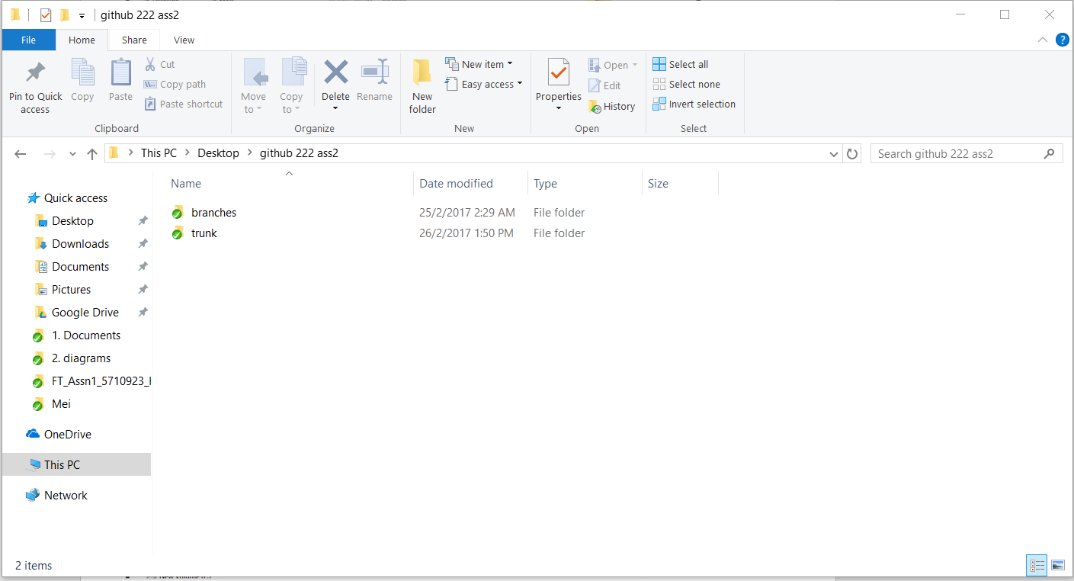

Screenshot #2 - VCS's listing of all the latest source files currently being managed

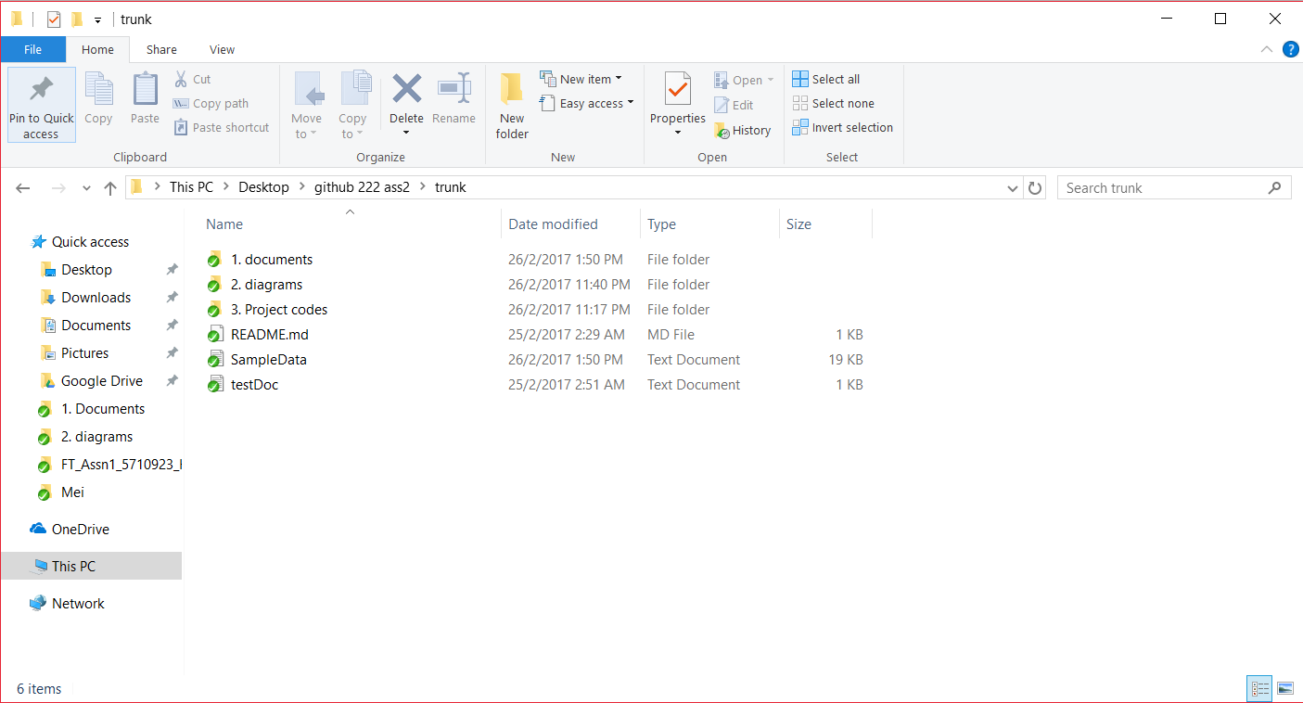

Screenshot #3 - Example using VCS's to check-out source files (it may be necessary to do >1 screen capture, depending on the software used)

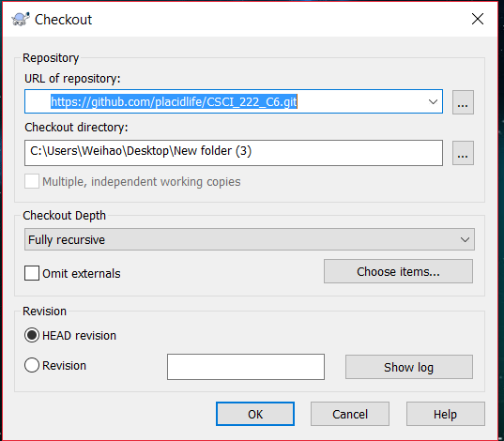

Screenshot #4 - Example using VCS's to check-in source files (it may be necessary to do >1 screen capture, depending on the software used)

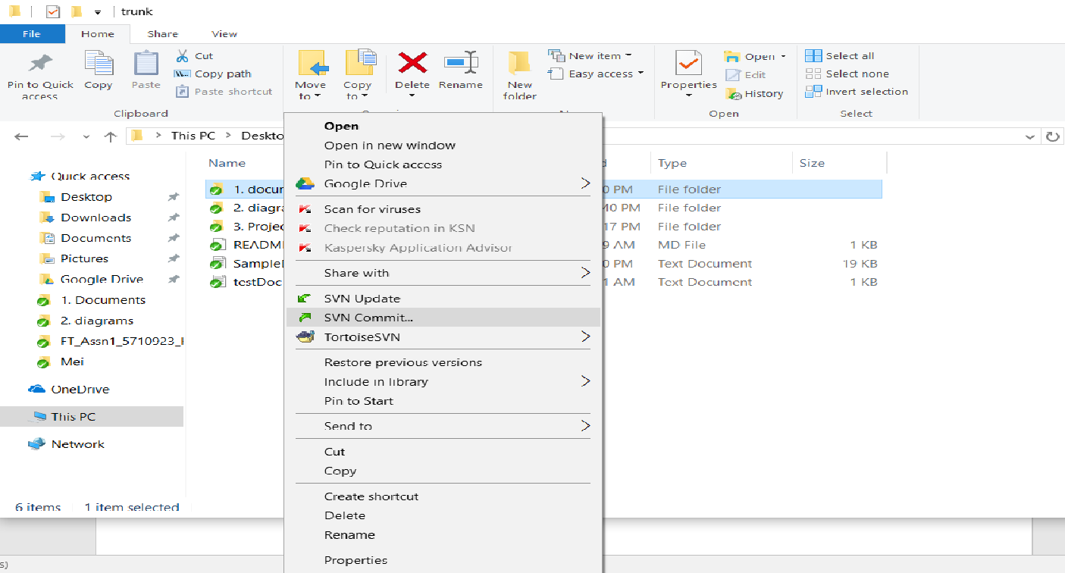

Screenshot #5 - Example using VCS's to display the change history / log (it may be necessary to do >1 screen capture, depending on the software used)

